ROLE CARDS

ROLE NAME

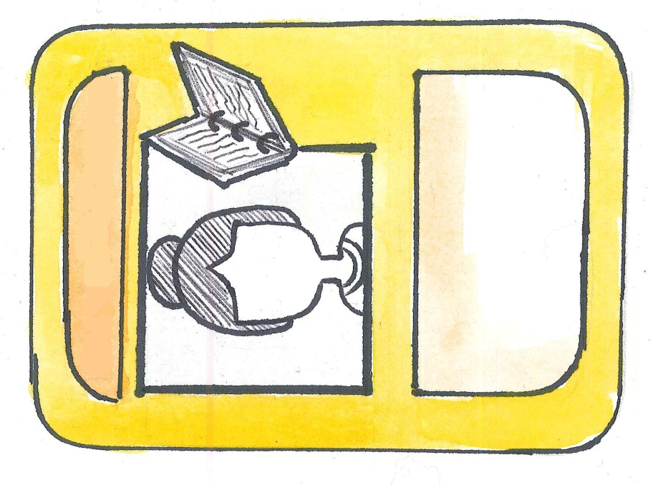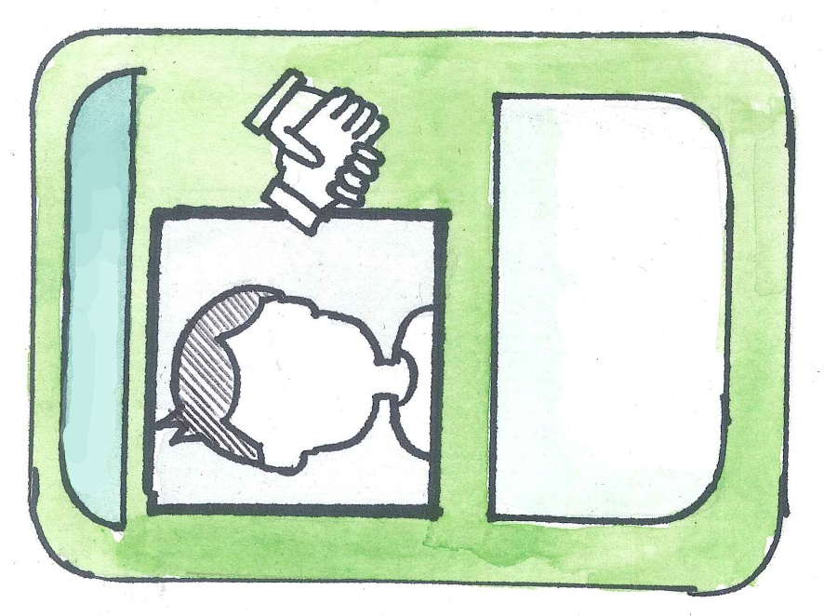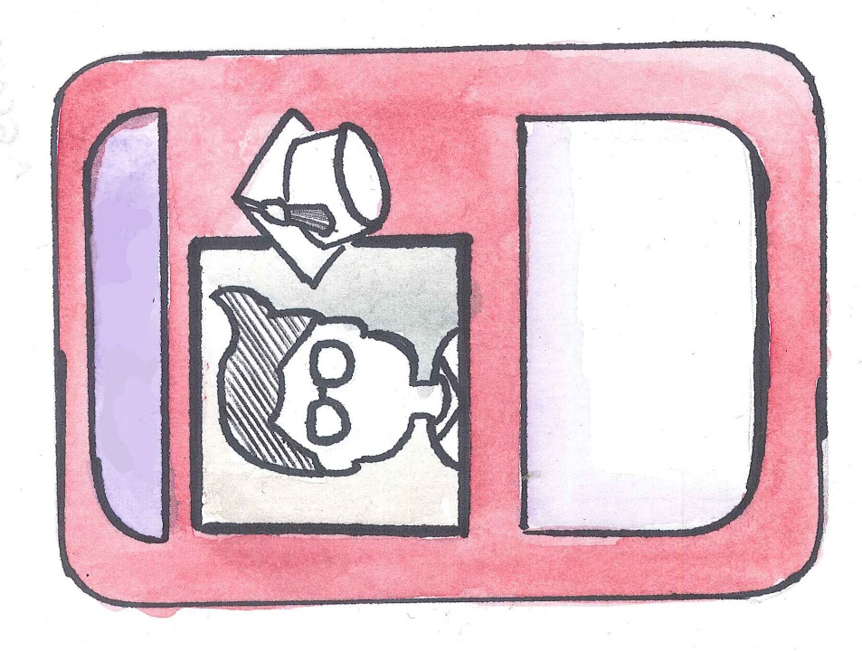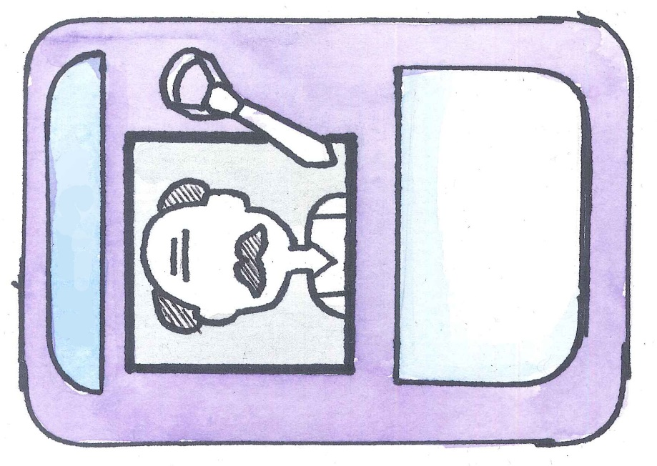

Add your role description here

Add your role description here

Add your role description here

Add your role description here

ROLE NAME

ROLE NAME

ROLE NAME

ROLE NAME

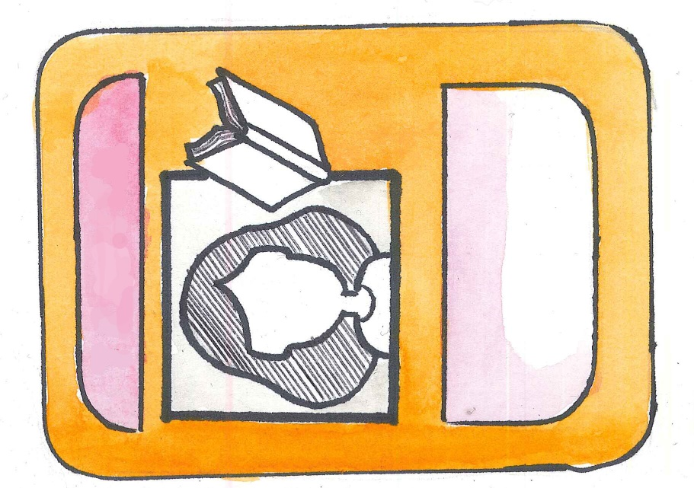

Add your role description here

ROLE NAME

QUESTION CARDS

Add you question here



Add you question here

Add you question here